Assignment 3 – TASK 1:
#include <stdio.h>
#include <string.h>
int main (){
int i,j,k,digit[4],score=0;
char table[5][6], str[20];
//printf("Enter User ID (4 digits): \n");
//scanf("%d",&digit);
srand(time(NULL)); //only once

for(i=0;i<=4;i++){
for(j=0;j<=5;j++){
table[i][j] = (rand()%(90-65))+65;
}
}

for(i=0;i<=4;i++){
for(j=0;j<=5;j++){
if(i==4 && j==0){
table[i][j] = '4';
}
if(i==4 && j==1){
table[i][j] = '0';
}
if(i==4 && j==2){
table[i][j] = '8';
}
if(i==4 && j==3){
table[i][j] = '0';
}
}
}

for(i=0;i<=4;i++){
printf("\n");
for(j=0;j<=5;j++){
printf(" %c",table[i][j]);

}
}

do{
printf("\nEnter search string: \n");
fflush(stdin);
gets(str);
fflush(stdin);

int len = strlen(str);
int count=0;
int k,searched=0,found=0;

for(i=0;i<=4;i++){
for(j=0;j<=5;j++){
for(k=0;k<=len;k++){
if(table[i][j]==str[k]){

searched+=1;
j++;

}else{

searched=0;
break;
} if(searched==len){
found=1;
break;}
}if(found==1)
break;
} if(found==1)
break;
}

if(found==1){
score++;
printf("%s is present: Score = %d\n\n",str, score);
}
else{
score-=1;
printf("%s is not present: Score = %d\n\n",str, score);
}

}while(strcmp(str, "END") != 0);

if (strcmp(str, "END") == 0){
for(i=0;i<=4;i++){
for(j=0;j<=5;j++){
table[i][j] = (rand()%26)+65;
}
}

for(i=0;i<=4;i++){
printf("\n");
for(j=0;j<=5;j++){
printf(" %c",table[i][j]);

}
}
}

return 0;
}
OUTPUT:
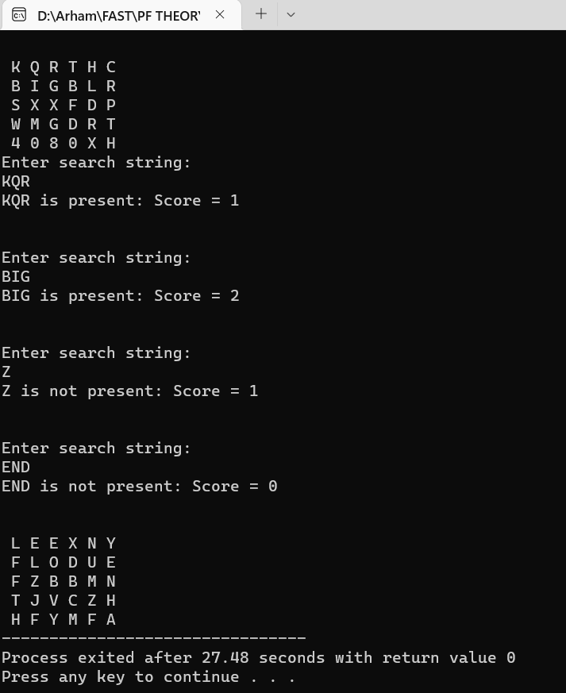

ASSIGNMENT 3 – TASK 2
#include <stdio.h>
#include <string.h>
void consonant(char arr[], int size, const int n) //function if word starts with consonant or y
{
int arr2[100];
int i, j = 0;

for (i = 0; i < size; i++)
{
arr2[i] = arr[i];
}

for (i = 0, j = 2; j < size; i++, j++)
{
arr[j] = arr2[i];
}

for (i = 0, j = size - 2; i < 2; i++, j++)
{
arr[i] = arr2[j];
}

arr[size] = 'a';
arr[size + 1] = 'y';
arr[size + 2] = '\0';

}

void yvowel(char arr[], int size, int flag) //function in case of y as a vowel
{
char arr2[100];
int i, j = 0;

for (i = 0; i < size; i++)
{
arr2[i] = arr[i];
}

for (i = flag, j = 0; i < size; i++, j++)
{
arr[j] = arr2[i];
}

for (i = 0, j = size - flag; j < size; i++, j++)
{
arr[j] = arr2[i];
}

arr[size] = 'a';
arr[size + 1] = 'y';
arr[size + 2] = '\0';
}

void schToSk(char arr[], int size) //function to change sch to sk
{
int arr2[100];
int i, j = 0;

for (i = 0; i < size; i++)
{
arr2[i] = arr[i];
}

for (i = 3, j < 0; i < size; i++, j++)
{
arr[j] = arr[i];
}

arr[size - 3] = 's';
arr[size - 2] = 'k';
arr[size - 1] = 'a';
arr[size] = 'y';
arr[size + 1] = '\0';
}

int main()
{
char inputStr[200];
printf("Name: Muhammad Arham Hussain Khan\t ID:22k-4080");
printf("Enter sentence to Encrypt: ");
fflush(stdin);
gets(inputStr);

//checking length of sentence to make code efficient
int i;
int length = 0;
for (i = 0; i < 200; i++)
{
if (inputStr[i] != '\0')
{
length++;
} else break;
}

//counting spaces to count words, then to generate 2D array to store words in it
int spaces = 0;
for (i = 0; i < length; i++)
{

if (inputStr[i] == 32)
{
spaces++;
} else continue;

}

//copying individual words in 2D array
int j, k;
int wordnum = spaces + 1;
char words[wordnum][15];
i = 0;
k = 0;
for (j = 0; j < length; j++)
{

if (inputStr[j] == 32)
{
i++;
k = 0;
continue;
}
else
{
words[i][k] = inputStr[j];
k++;
}

}
//for calculating length of each word
int len[30] = { 0 };
for (i = 0; i < wordnum; i++)
{

for (j = 0; j < 20; j++)
{
if ((words[i][j] >= 65 && words[i][j] <= 90) || (words[i][j] >= 97 && words[i][j] <= 122))
{
len[i]++;
} else break;

}
}
int flag, l, yflag = 0;
//Encrypting each word seperately
for (i = 0; i < wordnum; i++)
{
for (j = 0; j < len[i]; j++)
{
//Y first letter
if (words[i][0] == 'y' || words[i][0] == 'Y')
{
consonant(words[i], len[i], 2);
break;
}
else if (words[i][0]=='A' || words[i][0]=='a' || words[i][0]=='E' || words[i][0]=='e' //starts with vowel
|| words[i][0]=='I' || words[i][0]=='i' || words[i][0]=='O'
|| words[i][0]=='o' || words[i][0]=='U' || words[i][0]=='u')
{
words[i][len[i]] = 'w';
words[i][len[i] + 1] = 'a';
words[i][len[i] + 2] = 'y';
words[i][len[i] + 3] = '\0';
break;
} else if ((words[i][0] == 's' || words[i][0] == 'S') && words[i][1] == 'c' && words[i][2] == 'h') //schToSk to sk
{
schToSk(words[i], len[i]);
break;
} else //starts with consonant
{
for (l = 1; l < len[i]; l++)
{
if (words[i][l] == 'y' || words[i][l] == 'Y')
yflag = 1;
flag = 0;
{ for (k = 0; k < len[i]; k++)
{
if (words[i][k]=='A' || words[i][k]=='a' || words[i][k]=='E' || words[i][k]=='e'
|| words[i][k]=='I' || words[i][k]=='i' || words[i][k]=='O'
|| words[i][k]=='o' || words[i][k]=='U' || words[i][k]=='u')
{
flag = k;
break;
}
}

}

}

}
if (yflag != 1)
{
consonant(words[i], len[i], 2);
break;
} else
{
yvowel(words[i], len[i], flag);
break;
}

}
}

for (i = 0; i < wordnum; i++) //toggling case
{
for (j = 0; j < len[i]; j++)
{
if (words[i][j] >= 65 && words[i][j] <= 90)
{
words[i][j] = words[i][j] + 32;
words[i][0] = words[i][0] - 32;
break;
}
}
}
printf("String after encryption: 22K-4080 ");
for (i = 0; i < wordnum; i++)
{
printf("%s ", words[i]);
}

return 0;
}
OUTPUT:
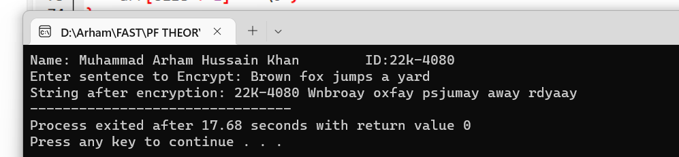
ASSIGNMENT 3 – TASK 3:
#include <stdio.h>
#include <string.h>

struct student
{
char StdID[9];
char Name[40];
float Quiz;
float Assigment;
float MidOne;
float MidTwo;
float Final;
float GPA;
};

struct ClassInfo
{
int TotalStudents;
float MidOne;
float MidTwo;
float Final;
float CalAverage;
};

int NoOfStudents = 7;

char PrintOptMenu();

void accumulateEvaluations(struct student allStudents[], int index, char task);

float getGPA(float total);

void smartFind(struct student allStudents[], char str[40]);

int main()
{
int i,j;
char task;

struct student data[NoOfStudents];
struct ClassInfo record = {NoOfStudents, 0, 0, 0, 0};

float max = 0;
char maxId[9];

int fail = 0;
char failed[NoOfStudents][9];

char str[40];

for (i = 0; i < NoOfStudents; i++)
{
float total = 0;
printf("Enter data for %d Student ", i + 1);

// Student ID
printf("\nEnter student ID :- ");

fflush(stdin);
gets(data[i].StdID);
fflush(stdin);

for (j = 0; j < i; j++)
{
if (strcmp(data[i].StdID, data[j].StdID) == 0)
{
printf("\nStudent ID already exists, Please Enter Data For Another Student\n");
printf("\nEnter student ID again: ");
fflush(stdin);
gets(data[i].StdID);
j = i;
}
}

// Student Name
printf("\nEnter Student Name: ");
fflush(stdin);
gets(data[i].Name);
fflush(stdin);

// Student Scores
printf("\nEnter marks scored in Quiz: ");
scanf("%f", &data[i].Quiz);

printf("\nEnter marks scored in Assigment: ");
scanf("%f", &data[i].Assigment);

printf("\nEnter marks scored in MidOne: ");
scanf("%f", &data[i].MidOne);
record.MidOne += data[i].MidOne;

printf("\nEnter marks scored in MidTwo: ");
scanf("%f", &data[i].MidTwo);
record.MidTwo += data[i].MidTwo;

printf("\nEnter marks scored in Final: ");
scanf("%f", &data[i].Final);
record.Final += data[i].Final;

total += data[i].Quiz + data[i].Assigment + data[i].MidOne + data[i].MidTwo + data[i].Final;

if (total < 50)
{
strcpy(failed[fail], data[i].StdID);
fail++;
}

record.CalAverage += total;

if (total > max)
{
max = total;
strcpy(maxId, data[i].StdID);
}
}

task = PrintOptMenu();
char ID[9];

while (task != 'e')
{
switch (task)
{
case 'a':
printf("\nMy Name is:Muhammad Arham Hussain Khan ID: 22K-4080\n");
printf("\tID\tName\tGPA\n");
for (i = 0; i < NoOfStudents; i++)
{
accumulateEvaluations(data, i, task);
printf("\n");
}
break;

case 'g':
printf("Enter ID you wish to view GPA of: ");

fflush(stdin);
gets(ID);
fflush(stdin);

for (i = 0; i < NoOfStudents; i++)
{
if (strcmp(ID, data[i].StdID) == 0)
{
printf("\nMy Name:Muhammad Arham Hussain Khan ID: 22K-4080\n\n");
printf("\tID\tName\tGPA\n");
accumulateEvaluations(data, i, task);
break;
}
}
break;

case 's':
record.MidOne /= NoOfStudents;
record.MidTwo /= NoOfStudents;
record.Final /= NoOfStudents;
record.CalAverage /= NoOfStudents;
printf("Total student TotalStudents is: %d\n", record.TotalStudents);
printf("Average score mid 1 is: %.2f\n", record.MidOne);
printf("Average score mid 2 is: %.2f\n", record.MidTwo);
printf("Average score Final is: %.2f\n", record.Final);
printf("Average total score is: %.2f\n", record.CalAverage);
printf("Student ID %s has max score of %.2f\n", maxId, max);
printf("List of student IDs who did not pass the course: \n");
for (i = 0; i < fail; i++)
{
puts(failed[i]);
}
printf("\nThank you, my ID is 22K-4080 and my Name is Muhammad Arham\n");
break;

case 'f':
for (i = 0; i < NoOfStudents; i++)
{
accumulateEvaluations(data, i, task);
}
printf("\nEnter student Id/Name you wish to find data of: ");
fflush(stdin);
gets(str);
printf("\nMy Name is:Muhammad Arham ID: 22K-4080 Function being called: Smart Find\n\n");
smartFind(data, str);
break;

case 'r':
strcpy(data[7].StdID, "22K-4080");
strcpy(data[7].Name, "Muhammad Arham");
data[7].Quiz = 8.0;
data[7].Assigment = 9.0;
data[7].MidOne = 11.5;
data[7].MidTwo = 10.87;
data[7].Final = 48.0;
data[7].GPA = 3.67;
printf("\nMy details:\n");
printf("\n\nID\tName\tQuiz\t Assigment\tMidOne\tMidTwo\tFinal\tGPA\n");
printf("%s\t%s\t%.2f\t %.2f\t%.2f\t%.2f\t%.2f\t%.2f points\n", data[7].StdID, data[7].Name, data[7].Quiz, data[7].Assigment, data[7].MidOne, data[7].MidTwo, data[7].Final, data[7].GPA);
break;
}
task = PrintOptMenu();
}
}
char PrintOptMenu()
{
char task;
printf("\n");
printf("\nEnter appropriate letter for your choice of action:");
printf("\n g. For printing GPA of a specific student ID.");
printf("\n a. For printing GPA of all students in a tabular form.");
printf("\n r. For replacing the details of the student at the 7th index by your exact data.");
printf("\n f. For finding the details of a student using smartFind() function.");
printf("\n s. For printing the statistics of the class.");
printf("\n e. Exit the program\n");
printf("Enter here: ");
scanf(" %c", &task);
printf("\n\n");
return task;
}
void accumulateEvaluations(struct student allStudents[], int index, char task)
{
float total = 0;
total += allStudents[index].Quiz + allStudents[index].Assigment + allStudents[index].MidOne + allStudents[index].MidTwo + allStudents[index].Final;
float GPA = getGPA(total);
allStudents[index].GPA = GPA;

if (task != 'f')
printf("\t%s\t%s\t%.2f points", allStudents[index].StdID, allStudents[index].Name, GPA);
}

float getGPA(float total)

{
float GPA;
if (total >= 86)
{
GPA = 4.00;
}
else if (total >= 74)
{
GPA = 3.00;
}
else if (total >= 62)
{
GPA = 2.0;
}
else if (total >= 50)
{
GPA = 1.00;
}
else
GPA = 0.00;

return GPA;
}

void smartFind(struct student allStudents[], char str[40])
{
int i;
printf("\n\nID\t\tName\t\tQuiz\t Assigment\tMidOne\tMidTwo\tFinal\tGPA\n");
for (i = 0; i < NoOfStudents; i++)
{
if ((strcmp(strlwr(allStudents[i].StdID), strlwr(str)) == 0) || (strcmp(strlwr(allStudents[i].Name), strlwr(str)) == 0))
{
printf("%s\t%s\t%.2f\t %.2f\t\t%.2f\t%.2f\t%.2f\t%.2f points\n", allStudents[i].StdID, allStudents[i].Name, allStudents[i].Quiz, allStudents[i].Assigment, allStudents[i].MidOne, allStudents[i].MidTwo, allStudents[i].Final, allStudents[i].GPA);
return;
}
}
}

OUTPUT:
